**Think and Answer**

**Team ID: 804**

|  |  |
| --- | --- |
| **Team leader name** | Surbhi Kumari |
| **College** | Bharati Vidyapeeth College of Engineering |
| **Email** | itsmesurbhi27@gmail.com |
| **Date** | 24/11/2019 |

Please answer all the questions given below. You are allowed to use figures or diagrams to support your answer. Since these questions test your understanding of the whole subject, please refrain from directly asking for answers on Piazza.

**Section 1 - Simple Pendulum**

Q1) Find the eigenvalues of Simple Pendulum at equilibrium point (0,0). Is the system stable or unstable at this point? (2)

Ans.

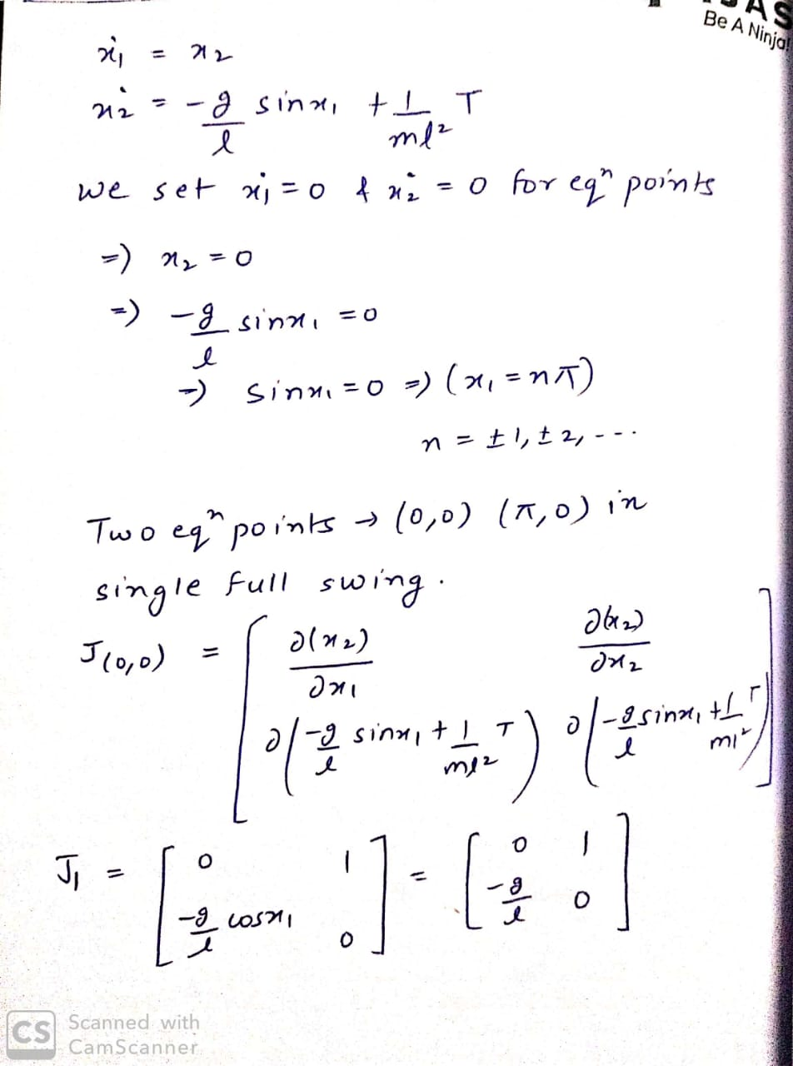

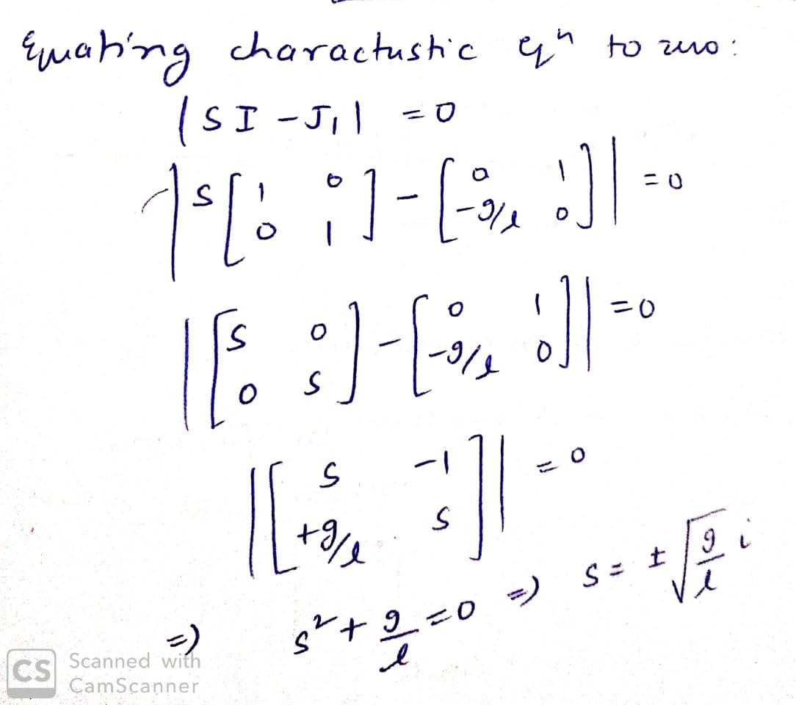

The eigen values at equilibrium point **(0,0)** are purely imaginary, i.e., system is **marginally stable**.

Q2) Can the Pendulum be balanced at an arbitrary point such as (2π/3,0) using the Pole Placement or LQR controller? Why? Why Not? Justify your answer. (3)

Ans. Yes, the pendulum can be balanced at any arbitrary point using a control input i.e., external torque in this system. Also, the rank of controllability matrix of the system is equal to the number of state variables. Here (1/m*L2) = 4 for m= 1 and

L= 0.5.

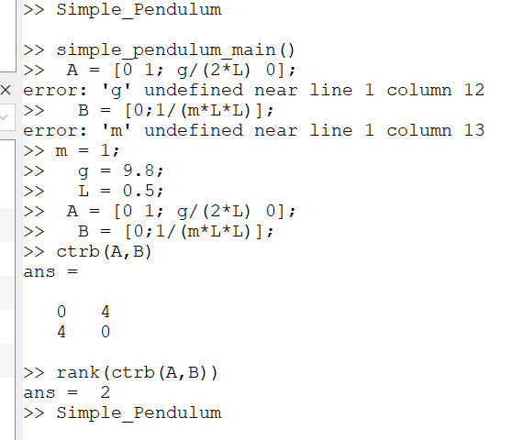

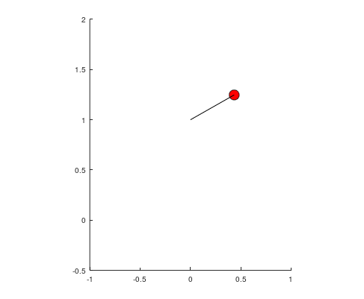

In the above figure the pendulum is made stable at (2π/3,0).

**Section 2 - Mass Spring System**

Q3) Derive the equations of Mass Spring system. (3)

Ans.

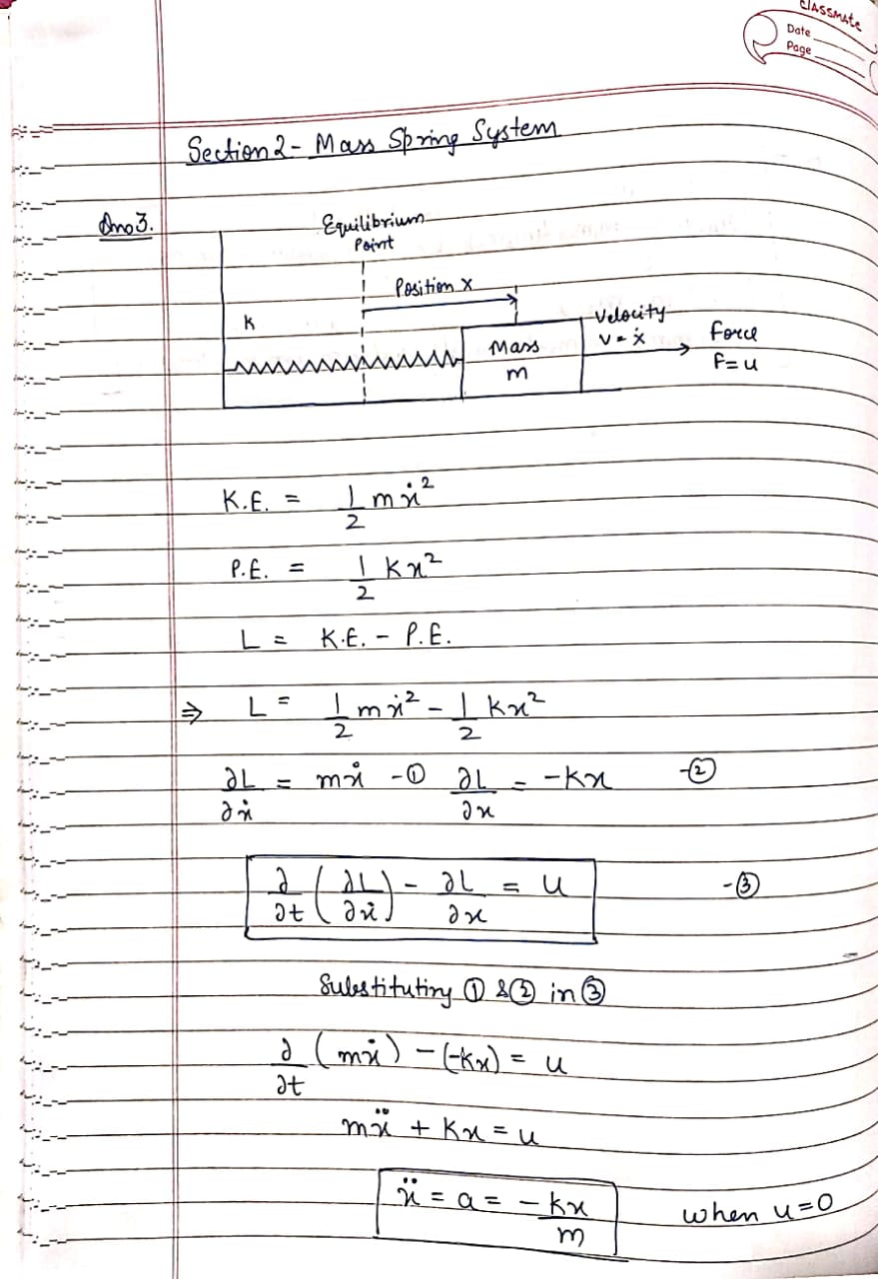

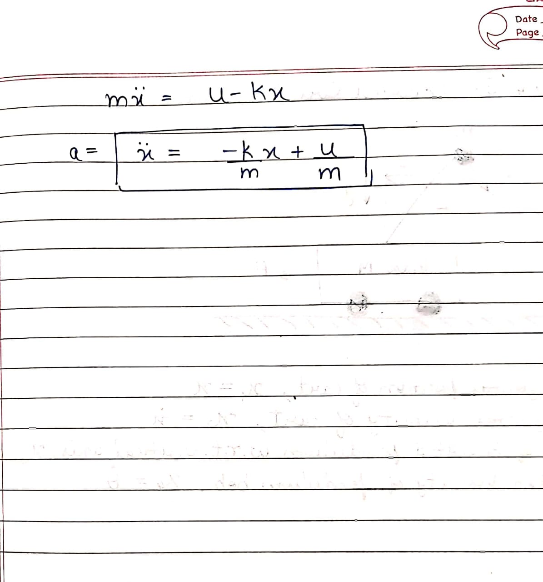

Q4) Is the mass spring system a linear system or non-linear? Justify your answer. (1)

Ans. The mass spring system is a linear system as the force exerted on the mass is directly proportional to the distance (x) moved by the mass from the mean position.

If we scale the input (distance x) by a factor of alpha , then the output(force F) also gets scaled by the same factor.

Q5) Can the mass spring system be driven to arbitrary state (0.8, 0) using pole placement controller? (Assuming 0.8 is the position and 0 is the velocity). (1)

Ans. Yes, it is possible to drive system to an arbitrary point using pole placement controller. We have done the same in Octave.

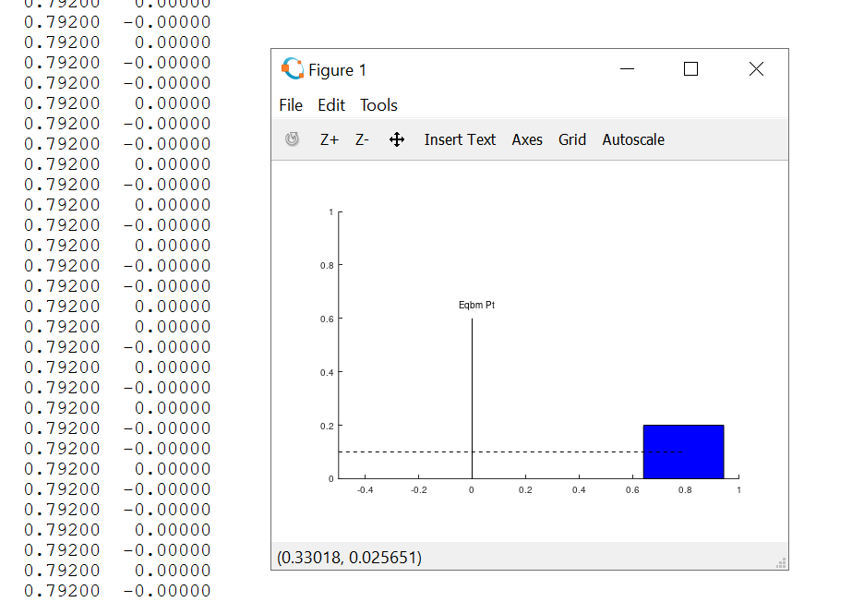

As seen from the image, we have brought the mass to an arbitrary point

**Section 3 - Simple Pulley**

Q6) Under what conditions, will the system remain perfectly at rest? Justify your answer. (1)

Ans. The simple pulley system will remain at rest when we consider the external force u = 0. Under this condition when m1 is equal to m2 i.e. both the masses are equal, the system will be at absolute rest. When u ≠ 0 i.e. external force is present , in that case stability can be achieved if u = (((m2 – m1)*g)/(m1+m2))*r is solved.

Q7) How many equilibrium points does the system have? Are they stable or unstable? Justify your answer. (2)

Ans. There are no equilibrium points in simple pulley system as it all depends on the mass of the body. If the masses are equal then every point will be equilibrium point (stable) and if the masses are not equal then the system cannot be brought to an equilibrium position.

**Section 4 - Complex Pulley**

Q8) Derive the equations of motion for the complex pulley system. (5)

Ans.

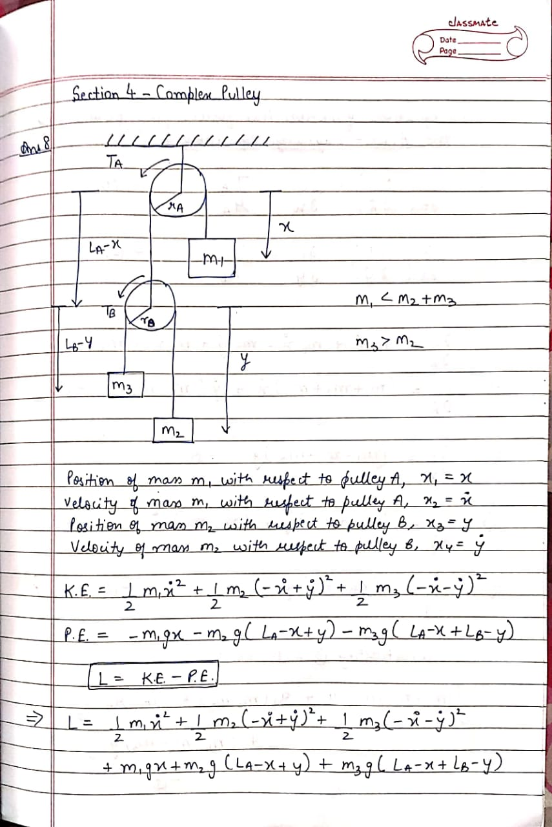

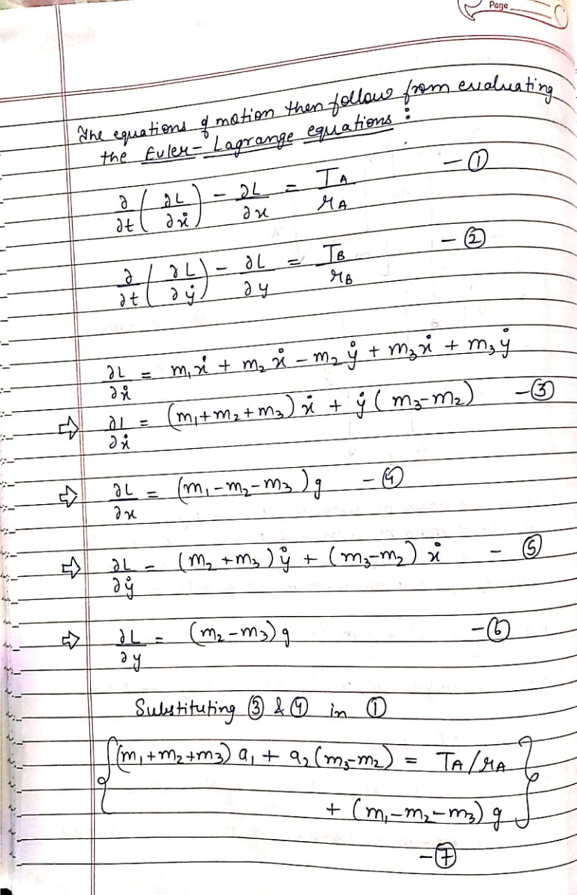

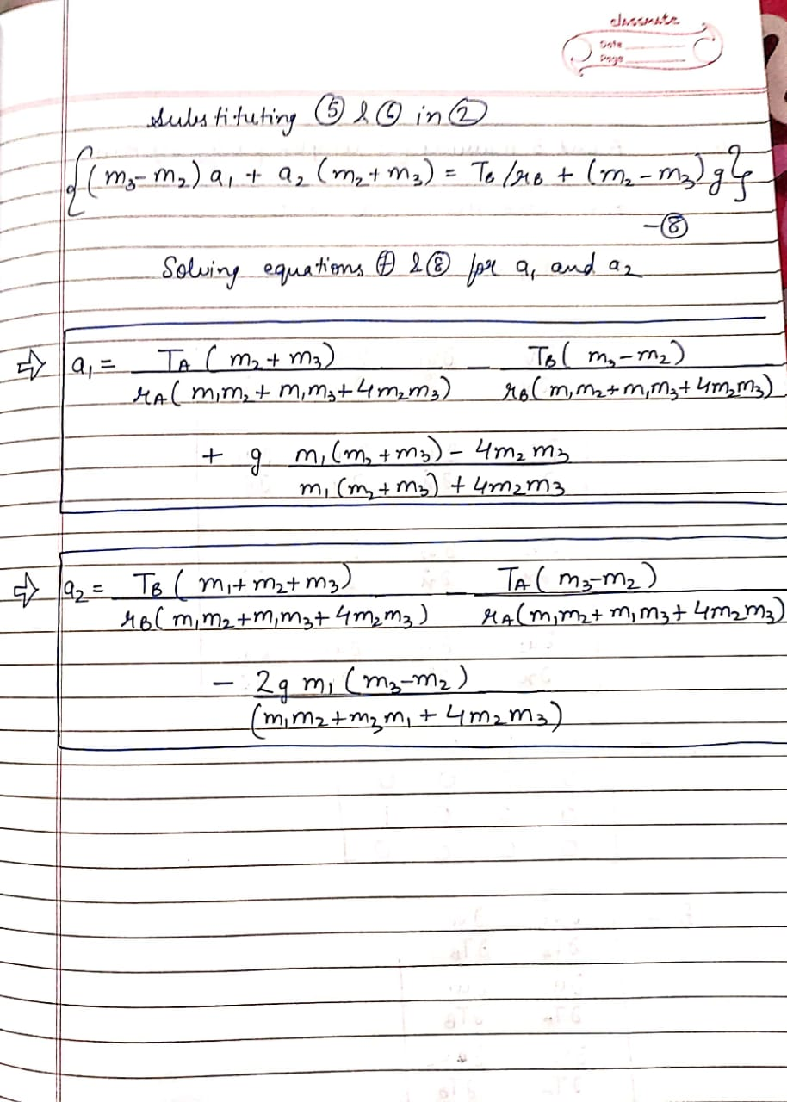

Q9) Derive the A and B matrices for the complex pulley system. Is the system linear or non-linear? (4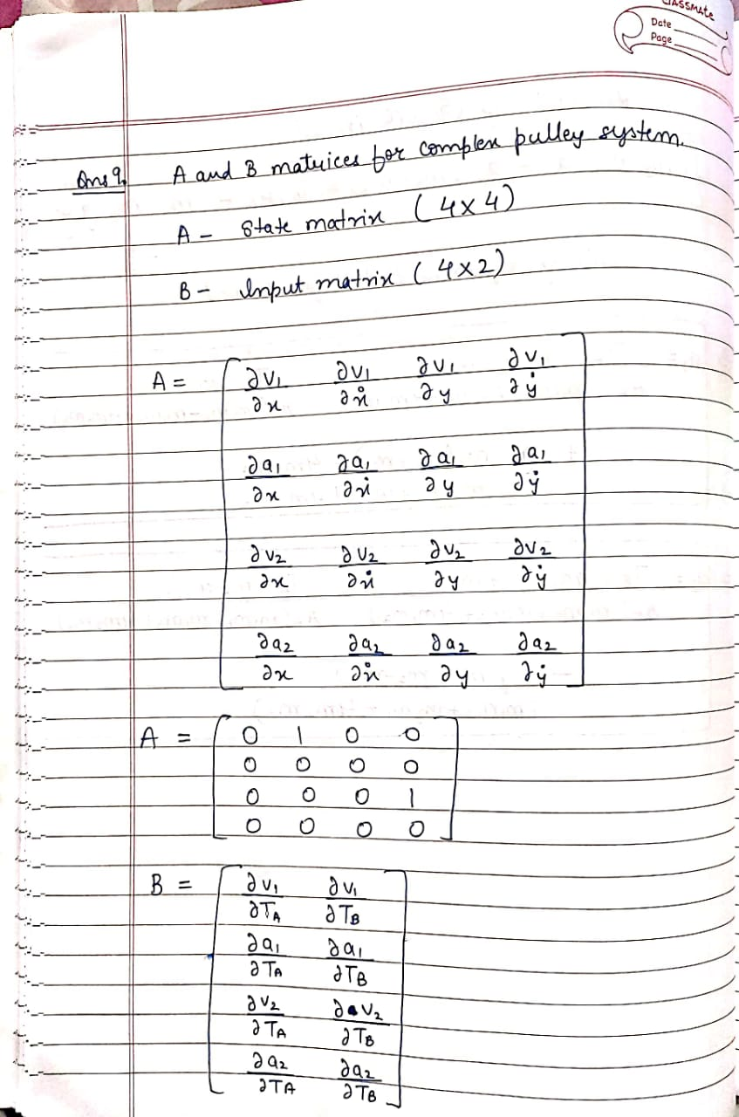

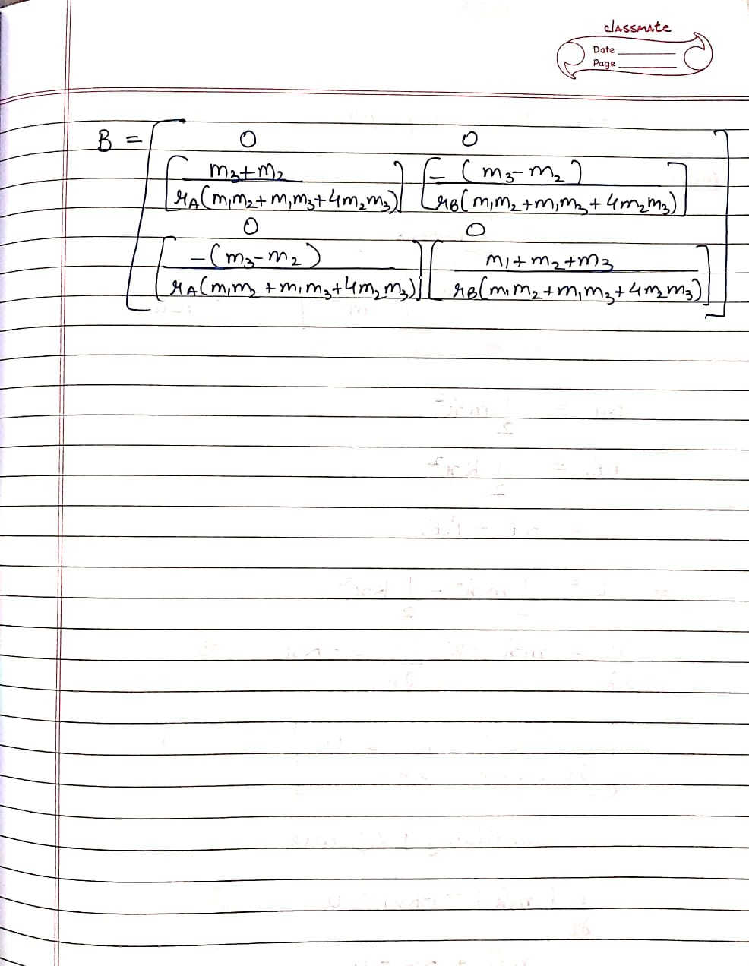

The complex pulley system is non linear in nature, because the output is not linearly dependent on the input. We have converted it into a linear system by expressing it in the form of equation x’(t) = A*x(t) + B*u(t).

Q10) Under what conditions, will the system remain perfectly at rest? Justify your answer. (3)

Ans. The complex pulley will remain perfectly at rest when the external forces i.e. the torques being applied on the pulleys (Ta and Tb) are zero. Under this condition from the acceleration equations we get

* (m1 * m3) + (m1 * m2) = (4*m2*m3)
* m3 = m2

When these two conditions are obeyed, the system will remain at rest.

**Section 5 - Inverted Cart Pendulum**

Q11) Derive the equations of motion for the inverted cart pendulum system. Is this system linear or non-linear? Why? (7)

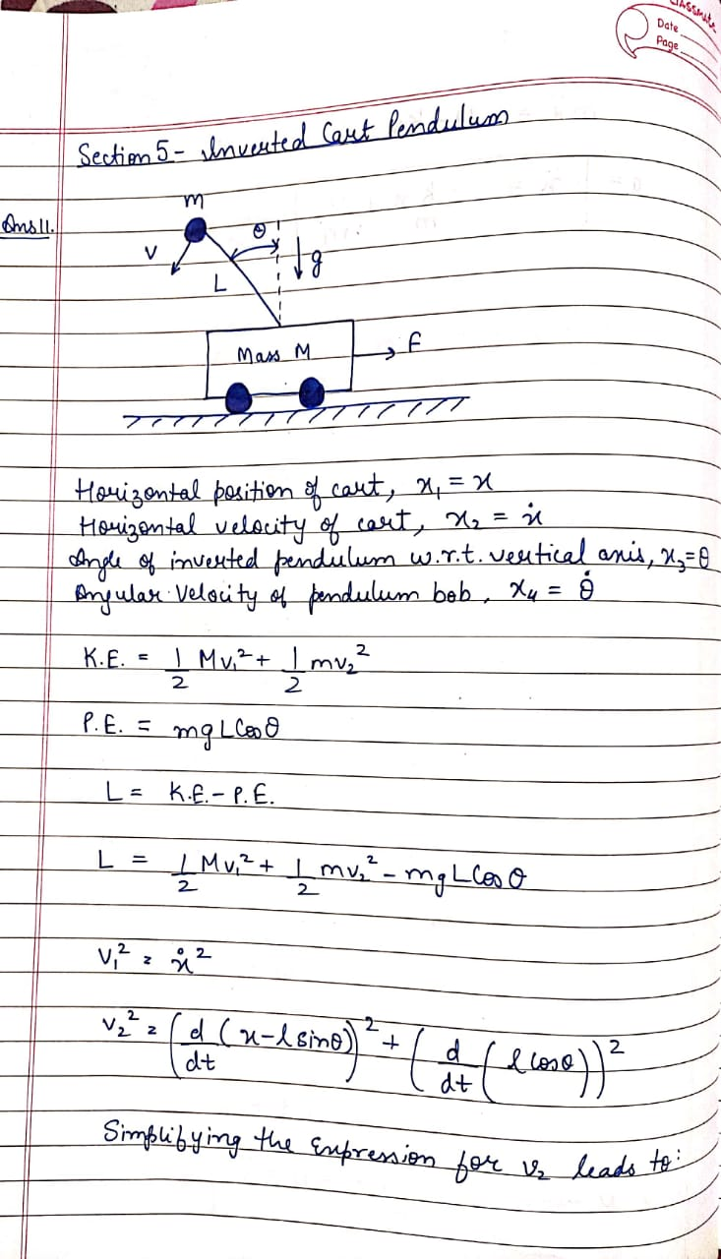

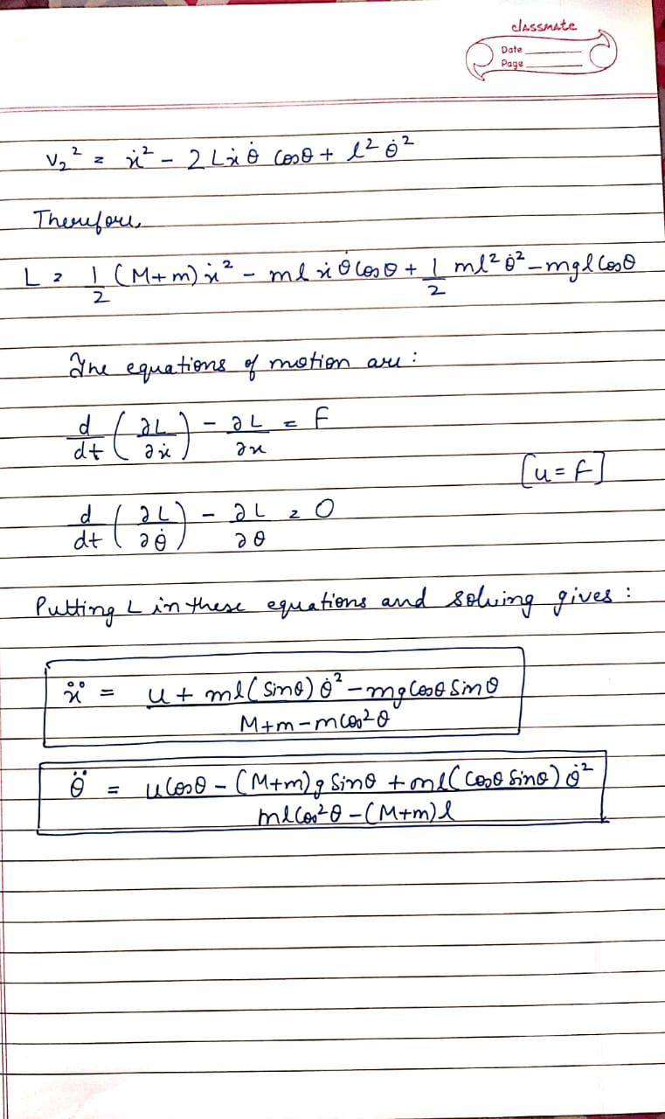

This system is non linear in nature because the changes made in the input do not reflect in the output of the system.

Q12) How many equilibrium points does the inverted cart pendulum system have? Categorize them as stable or unstable? (3)

Ans. The cart pendulum system has two equilibrium points **(0,0,0,0)** and **(0,0, π,0).**

At point (0,0,0,0) the system is **unstable** and at (0,0, π,0) the system is **stable**.

